The Grand Lodge of Canada in the Province of Ontario, A.F & A.M.

Ottawa District 1
THIS CERTIFIES THAT

[Name]
Has successfully completed the required components to be recognized as a SENIOR RITUALIST within this program
Dated this [Day] day of [Date]
 | 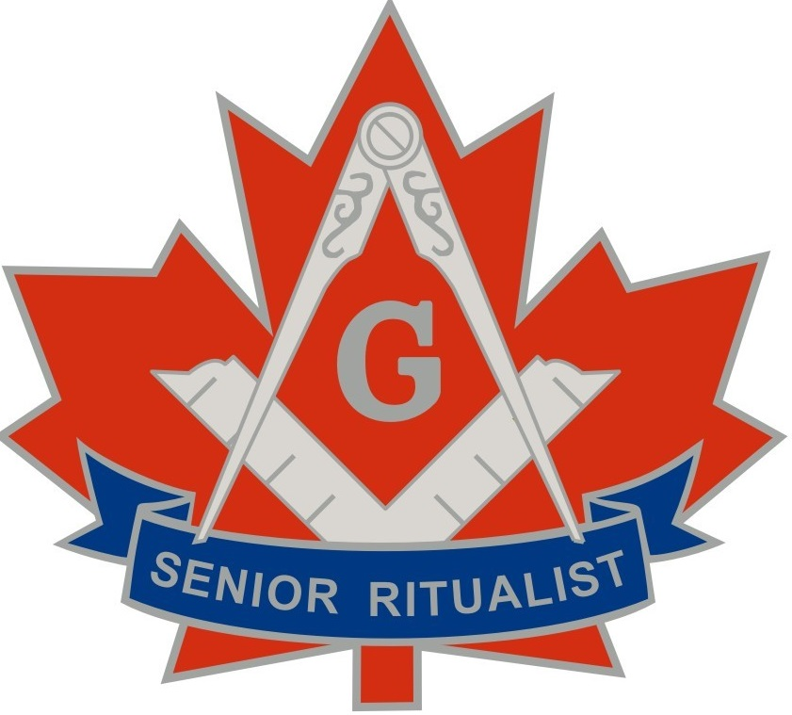
Worshipful Master |  | Secretary

